**TI BYTE Simulation Exercise**

**Week 1 : RC Circuits**

* **Question 1:**

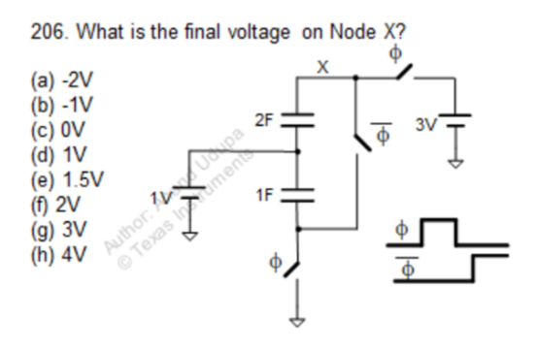

* **QUCS Circuit:**

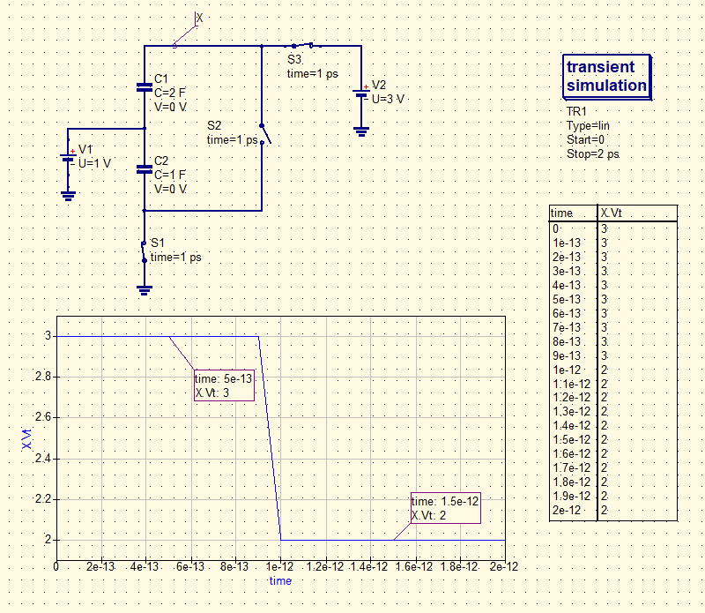

* **X is used to label the node and find the voltage at that node.**
* **Switches S1 and S3 are initially closed at t = 0, and S2 is opened.**
* **At t = 1 ps, the switches S1 and S3 are opened, and switch S2 is turned closed.**
* **QUCS Result:**

**Therefore, from the simulation, we get our answer as:**

**Vx = 2V**

**Answer: (f)**

* **Conclusion:**
* **Since the resistance in these circuits are 0, the voltage sources provide Impulse currents, and thus the capacitors C1 and C2 are charged instantaneously at t = 0, up to 2V and 1V respectively.**
* **The voltage at X at t = 0 is 3V.**
* **At t = 1 ps, when S1 and S3 are opened and S2 is closed, the capacitors C1 and C2 share their charges and instantaneously arrive at a final voltage of Vx = 2V.**
* **The slope in the simulated Cartesian diagram at t = 1 ps is due to the fact that, the step in the Transient simulation was taken as 0.1 ps.**
* **Question 2:**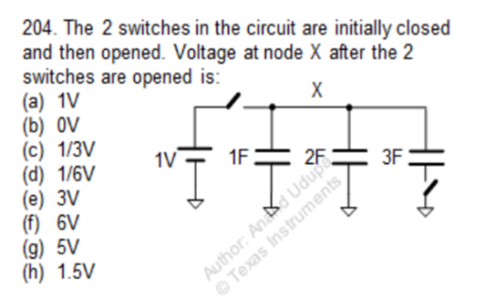
  + **QUCS Circuit:**

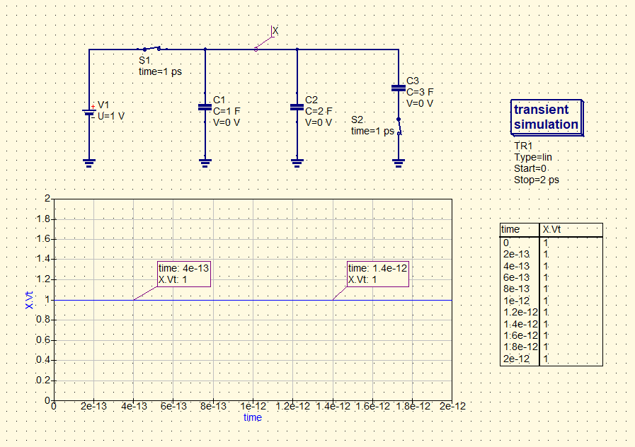

* **The node X is used to find out the resulting voltage at that node.**
* **Switches S1 and S2 are initially closed at t = 0.**
* **At t = 1 ps, the switches S1 and S2 are opened.**
* **QUCS Result:**

**Therefore, from the simulation, we get our answer as:**

**Vx = 1V**

**Answer: (a)**

* **Conclusion:**
* **Since the resistance in these circuits are 0, the voltage sources provide Impulse currents, and thus the capacitors C1, C2 and C3 all are charged instantaneously at t = 0, up to 1V.**
* **The voltage at X at t = 0 is 1V.**
* **At t = 1 ps, when S1 and S2 are opened, the lower plate of capacitor C3 becomes floating (or open-ended), and so no current flow will occur through that.**
* **Alongside, since both capacitors C1 and C2 both are charged up to 1V, thus no charge sharing occurs, it’s voltage remains at 1V. Thus the final voltage at node X is 1V.**